**9th Annual Beaver Island Sustainability Fair!**

**Tuesday 6/18:**    
 **9:30am** Mushroom prese**n**tation & foray @ CMU bio station   
 **10am – All Day** Solar installation @Tara’s Meadow – drive by viewing  
 **2pm**  Celebrate the Island’s New Dark Sky Sanctuary! @BICC  
 **7pm** Opening remarks BISF Week @BI Community Center (BICC)  
 **7:15pm** Opening Music, @BICC Melissa Welke  
 **7:45pm** BI Dark Sky Project @BICC Bill Markey, Cynthia Johnson  
 **8:15pm** Night Sky Presentation, @BICC Justin Miller  
 **10pm** Night sky photography @Whiskey Point (weather permitting)

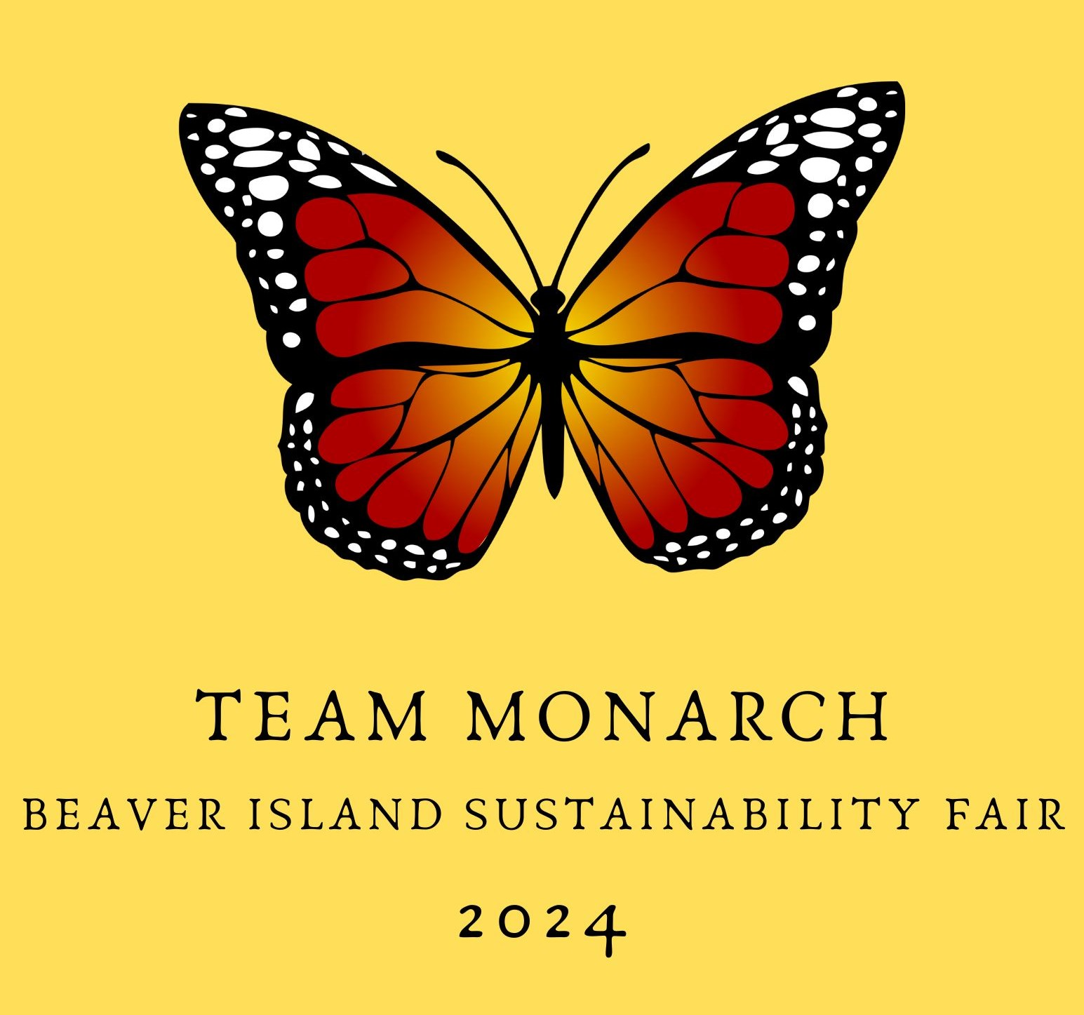

2024

**Wednesday 6/19:**   
 **10am** Native Plant Hike @Port St James Hidden Valley Trail **1pm** Mushroom Log Inoculation @Heritage Park

**Thursday 6/20:**   
 **10am** Agrivoltaics – Solar + Agriculture @Print Shop Museum   
 **1pm** Native Garden & Monarch Field Activity @Tara’s Meadow



**Friday 6/21:**    
 **10am** Wave Energy Converter Demonstration @CMU Boathouse, Whiskey Point   
 **1pm**  Monarch Butterflies: Preservation Presentation @BI Community Center   
 **7pm** Community Story Sharing @BICC - Why Sustainability? What matters to you?    
 **7:30pm** The Pairs Concert @BICC



**Saturday 6/22:**    
 **9am**  BI Sustainability Fair Opening @Paradise Bay: Water Ceremony, Celtic Blessing  
 **11am** Energy Audits & Energy Efficiency Demonstration @Print Shop Museum

**Map of Event Locations on Back, or scan   
QR Code**

**Saturday Afternoon at Gregg Hall (BI Christian Church)**   
 **12pm** Silent Auction & Sustainability Info Tables Open  
 **12pm-12:45** Public Feast! Taco Bar, beverages & desserts! $10 donation requested  
 **12:20pm** Welcome; Environmental Awards 2024   
 **12:30pm** BI Smart Energy Team Updates: What’s possible for Island Energy Resiliency?   
 **1pm** #1 Raffle     
  **1:15pm** Local Foods Systems: Permaculture Presentation & Community Roundtable   
  **2:45pm**  #2 Raffle  
  **3pm** Organic Waste Options for Communities (Emmet County Recycling)  
  **3:30pm**  #3 Raffle & Silent Auction Ends  
**3:30pm – 4:30** Info tables remain open  
  **4:30pm** Close of BISF 2024

Z

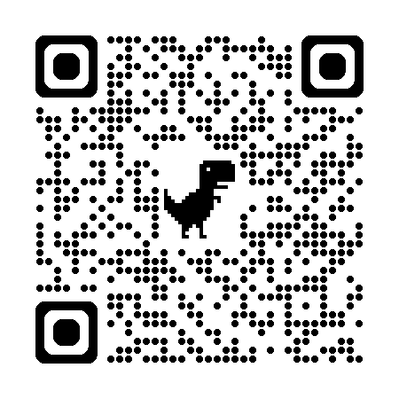

                                  

**The Annual Fair is a program of the Beaver Island Sustainability Initiative  
For info & sponsors:** [**www.tarasmeadow/bisf**](http://www.tarasmeadow/bisf)**. Follow on FB @Beaver Island Sustainability Initiative**

